Computer Architecture: CPU, Cores, RAM, and Cache
Computer architecture refers to the conceptual design and fundamental operational structure of a computer system. It defines how various hardware components interact to process information, execute instructions, and deliver overall system performance.
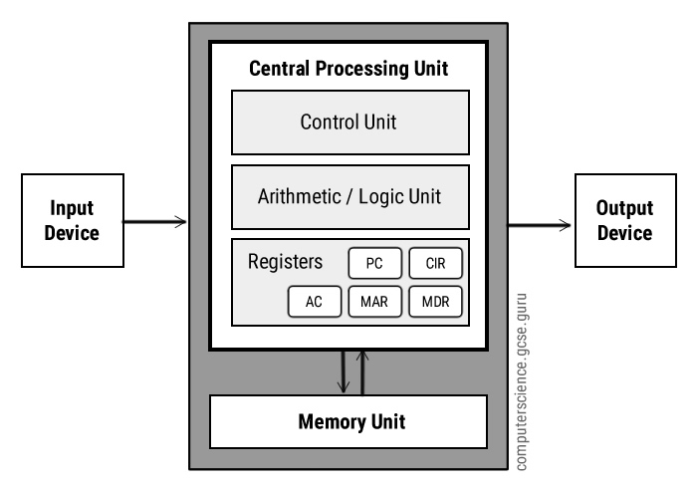
Central Processing Unit (CPU), processor cores, Random Access Memory (RAM), cache memory, and long-term storage (SSD/HDD) are the primary components that determine a computer's efficiency and speed. Together, these elements work in harmony to ensure that computing tasks are performed accurately, quickly, and reliably. Understanding these components is crucial for anyone interested in how computers operate.
Central Processing Unit (CPU):
The CPU, often called the “brain” of the computer, is the central component responsible for executing instructions from programs and operating systems. It carries out all arithmetic, logical, control, and input/output operations, ensuring smooth communication between different parts of the computer. In simple terms, the CPU interprets the instructions given by software and performs the necessary actions to produce the desired results.
Internal Components of a CPU:
1. Arithmetic Logic Unit (ALU): Handles mathematical calculations and logical operations.
2. Control Unit (CU): Directs the flow of data between the CPU and other components.
3. Registers: Small, high-speed storage locations used to hold data temporarily during processing.
4. Cache: Ultra-fast memory that stores frequently used instructions and data to speed up access.
CPU Execution Cycle:
1. Fetch: Retrieves the next instruction from main memory (RAM).
2. Decode: The Control Unit interprets the instruction to understand what action is required.
3. Execute: The ALU or other units carry out the instruction.
4. Write Back: The result of the operation is stored back in memory or a register for future use.
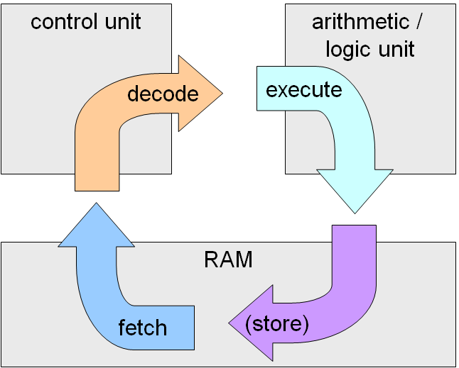

CPU Cores:
A CPU core is an individual processing unit within a processor capable of performing tasks independently.
a. Single-Core Processors: Can execute only one instruction at a time. They are simple and energy-efficient but are slower when handling multiple tasks.
b. Multi-Core Processors: Contain two or more cores, allowing multiple instructions to be processed simultaneously. This improves performance for tasks like gaming, multimedia, and AI applications. The use of multi-core processors has become standard in modern computers to support multitasking and more complex operations efficiently.

Random Access Memory (RAM):
RAM is the main memory of a computer where data and instructions are temporarily stored while the CPU performs tasks. It is much larger than cache memory but slower in access speed. When the CPU cannot find required data in cache, it retrieves it from RAM. The more RAM a computer has, the more data it can handle simultaneously, which results in smoother performance, especially when running multiple applications at once.
Cache Memory:
Cache memory is a small, high-speed memory located inside or near the CPU. Its purpose is to store frequently accessed data to reduce the time needed to fetch information from RAM. By keeping the most commonly used instructions and data close to the CPU, cache memory helps maintain fast and efficient processing.

